***HSIP Open Essential Facility Data Updates: CR 26636***

***Background:*** Hazus contains baseline inventories for the U.S. provided in downloadable State databases in SQL format. These baseline inventories provide the user an out of the box capability to run Hazus analyses anywhere in the U.S. Updating these static data and disseminating to users could be a more efficient and a less manual process. As a result, the lag times associated with updates mean some of the datasets are significantly older and do not benefit from the latest HIFLD Open and other releases.

***Objective:*** Update Legacy Hazus State essential facility databases using HIFLD Open. Develop scripts, tools and support data to integrate and assign the attributes required for Hazus loss modelling. Explore and develop innovative solutions for dynamic data updates that can operate within the future OpenHazus platform deployed in a web environment.

***Consider OpenHazus options:*** For example, if a user is working on a study region online, are there innovative ways to connect to and include HIFLD data dynamically or will we need to download and process data. If not updated dynamically, would like to strive for ways to automate the preparation of the data so updates could be very frequent.

***Automation options***: Can we connect and download through API or need a manual download? If manual download, what format is best? We may need to utilize shape or .csv over geodatabase for Open Source GIS support.

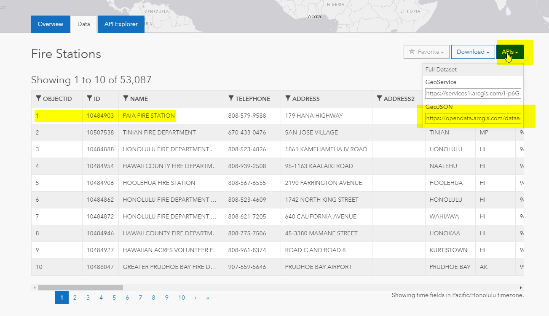

*Note that several States may have better/more complete EF data due to recent updates (AK, FL, HI, GU, MP, AS, PR, VI). For these we will update the same way and then compare the results using HIFLD Open with the existing and decide the best to use based on a QAQC review.*

***We will update all five Hazus Essential Facility classes:***

* ***Schools***
* ***Hospitals***
* ***Fire Stations***
* ***Police Stations***
* ***Emergency Operations Centers***

***Within each Hazus DB .mdf there are three tables for each inventory item:***

1. ***hzCareFlty*** contains the feature class (spatial data) as well as the general attributes across all hazard types
2. ***eqCareFlty*** contains the earthquake specific attributes
3. ***flCareFlty*** contains the flood specific attributes

**HIFLD Open to Hazus Target Tables:**

|  |  |
| --- | --- |
| **HIFLD Open** | **Hazus** |
| 1. Hospitals: <https://hifld-geoplatform.opendata.arcgis.com/datasets/hospitals> 2. Veterans Health Administration Medical Facilities: <https://hifld-geoplatform.opendata.arcgis.com/datasets/veterans-health-administration-medical-facilities> | hzCareFlty, eqCareFlty, flCareFlty |
| 1. Public Schools: <https://hifld-geoplatform.opendata.arcgis.com/datasets/public-schools> 2. Private Schools: <https://hifld-geoplatform.opendata.arcgis.com/datasets/private-schools> 3. Colleges and Universities: <https://hifld-geoplatform.opendata.arcgis.com/datasets/colleges-and-universities> 4. Supplemental Colleges: <https://hifld-geoplatform.opendata.arcgis.com/datasets/supplemental-colleges> | hzSchools, eqSchools, flSchools |
| 1. Fire Stations: <https://hifld-geoplatform.opendata.arcgis.com/datasets/fire-stations> | hzFireStation, eqFireStation, flFireStation |
| 1. Local Law Enforcement Locations: <https://hifld-geoplatform.opendata.arcgis.com/datasets/local-law-enforcement-locations> | hzPoliceStation, eqPoliceStation, flPoliceStation |
| 1. State Emergency Operations Centers (EOC): <https://hifld-geoplatform.opendata.arcgis.com/datasets/state-emergency-operations-centers-eoc> 2. Local Emergency Operations Centers (EOC): <https://hifld-geoplatform.opendata.arcgis.com/datasets/local-emergency-operations-centers-eoc> 3. Federal Emergency Management Agency (FEMA) Regional Headquarters: <https://hifld-geoplatform.opendata.arcgis.com/datasets/federal-emergency-management-agency-fema-regional-headquarters> | hzEmergencyCtr, eqEmergencyCtr, flEmergencyCtr |

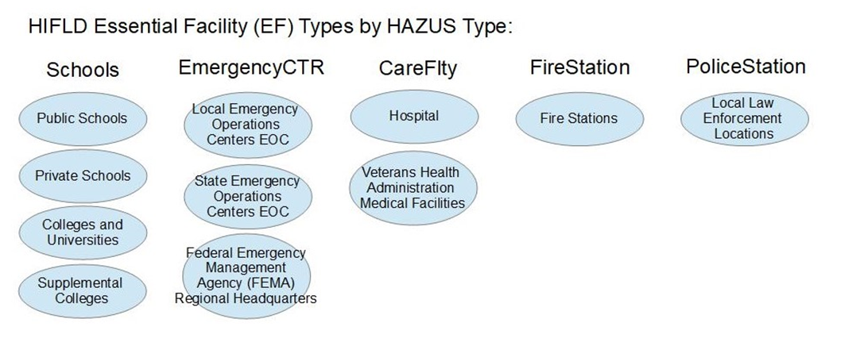

1. Design and develop methods to assign Hazus attributes that can be automated in OpenHazus and provided as a tool. This will include:

* Using num students (***hzSchool.NumStudents***) and num beds **(*hzCareFlty.NumBeds*)** for a more accurate estimate of building areas through config file and cdms_AEBMParameters based on FEMA P58
* Use of the calculated building areas to estimate replacements costs using the 2018 RS Means tables, non-residential county modification factors and Hazus content percentages
* Use of U.S. Census 2017 urban areas to adjust default eqBldgTypes from default wood types to masonry or concrete for urban vs rural areas, incorporating new hzCensusUrbanAreas feature class in CDMS.dbo.
* Use of Hazus occupancy to EQ building type mapping schemes to select the most common default eqBldgType, with new defaults for each State, urban vs rural and eqDesignLevel provided in a new CDMS.dbo table eqEFBldgTypeDefault.
* Use of Census median year-built date to estimate construction relative to seismic codes and NFIP benchmark years.
* Use of hzTract.BldgSchemeID that includes historic seismic zonation, and EQ Tech Manual guidance to assign likely seismic building code levels based on BenchMark dates, incorporating a new BenchMarkYears table into CDMS.dbo or config file.
* Use of NFIP entry date (***flSchemeMapping.EntryDate***) relative to MedianYearBuilt date to add 1 foot to default FFE, similar to the current flFFEValues for pre and post NFIP parameters
* Use of eqBldgType to assign General Building types so that flood and earthquake are assigned consistent General Building types

1. Update legacy Hazus site specific essential facility data based on this methodology
2. Update essential facility metadata pages and include dynamic links to HIFLD Open metadata pages.

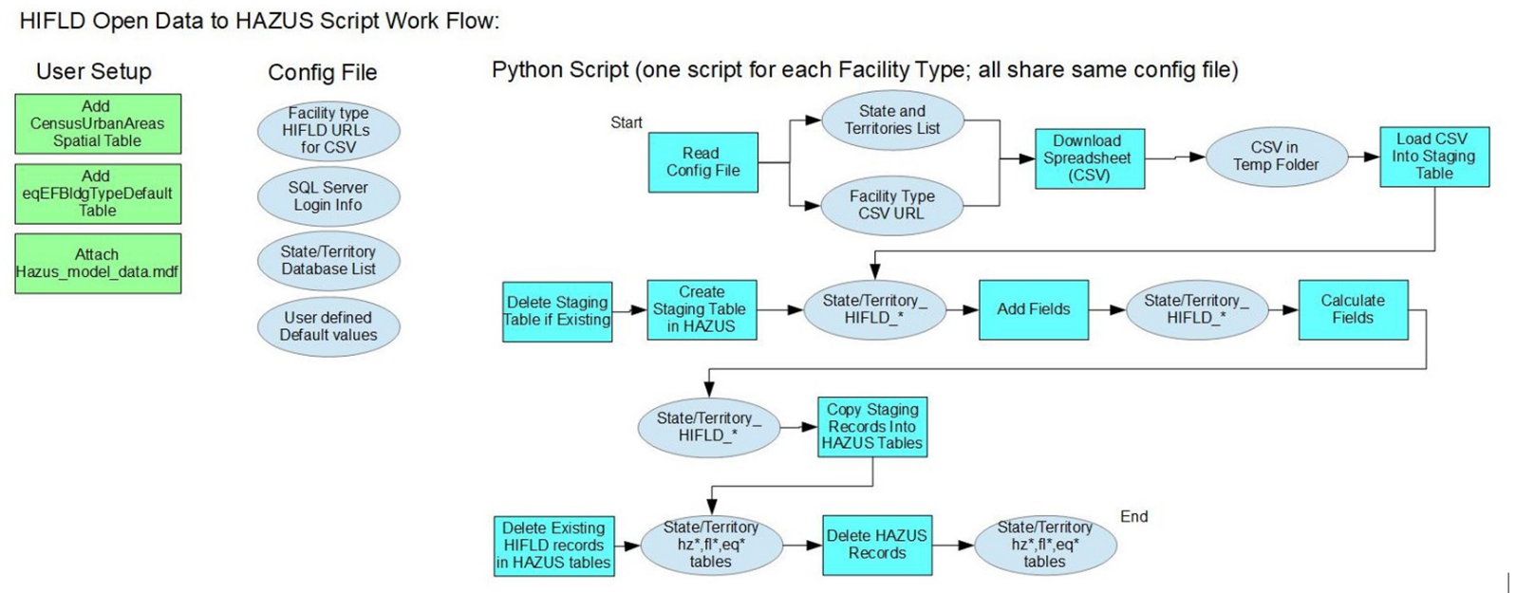

**Potential Future Enhancements:**

1. Develop methodology to link these facilities to site-specific building outlines or footprints through the use of GooglePlus codes or similar methods.
2. Update legacy Hazus aggregated GBS data (counts, squarefoootage, building and content valuations) based on these specific occupancy types (COM6, GOV2, EDU1 and EDU2) to ensure consistency between EF and GBS data
3. Complete research to support more refined assignments of building types and design levels, including leveraging the urban cluster data in addition to urban areas.

Five new tables will be created for staging and processing the data within each State DB:

1. HIFLD_CareFlty
2. HIFLD_Schools
3. HIFLD_FireStation
4. HIFLD_PoliceStation
5. HIFLD_EmergencyCtr

These tables will contain the initial HIFLD attributes, as well as Hazus required attributes and values needed for assignment of attributes, such as the urban flag. The latitude and longitude values will be provided; however, the script will remove the shape field to reduce table size and prevent significant State .dbo file size growth.